**Mortality due to a second wave of COVID-19 in Scotland:**

**The case for additional measures to protect the vulnerable**

Mark Woolhouse, University of Edinburgh

Chris Robertson, Health Protection Scotland

October 2nd 2020

Key points

* A response to the second wave that relies only on suppressing transmission will not, by itself, meet in full the policy objective of saving lives.
* Many thousands of people in Scotland could acquire life-threatening COVID-19 infections even after interventions to suppress the second wave take effect. If these interventions are less effective than hoped then this number could be far higher.
* Care homes are a particular and well-recognised concern but large numbers of high risk infections are expected in the wider community.

Retrospective analysis of the 1st wave

* A key part of the rationale for population-wide restrictions (‘lockdown’) in response to COVID-19 was that suppressing the virus (corresponding to R<1) keeps everyone safe, including the minority at greatest risk of severe consequences of infection.
* This is only partially true. Suppressing the virus is effective when incidence is low, but once suppression has failed (R>1) and incidence has risen a significant accumulation of further cases is inevitable, even once measures are introduced that bring the R value back below 1.
* Knowledge of the delay distribution between confirmation and death (Figure 1A) can be used to infer the time-line of the incidence of fatal infections during the first wave.
* This method suggests that 73% of those who died (77% of those aged 80+) are estimated to have been infected post March 23 lockdown (Figure 1B and Appendix 1).
* A second analysis assuming fixed delays gives similar results (Table 1), indicating that 2500 deaths (central estimate) during the first wave were due to infections acquired after March 23 lockdown.
* These deaths were not prevented by suppressing the virus.
* Approximately 45% of post-lockdown fatal infections (>1000) occurred outside care homes (Table 1). These deaths would not have been prevented by measures taken to protect care homes.

Scenario analysis for the 2nd wave

* The second wave is (so far) markedly less explosive than the first wave (doubling time 8-12 days rather than 3-4 days; R value 1.3-1.7 rather than >3)[1].
* This is to be expected given the measures still in place and the widespread changes in behaviour.
* Extrapolations of growth in case numbers based on an exponential increase (i.e. fixed doubling time) are pessimistic in that they imply no impact of measures implemented in the past 1-2 weeks whose effects are yet to be (fully) seen.
* We can use a simple epidemiological model to illustrate the relationship of time taken to reverse the growth in cases and the degree of suppression of transmission (post-intervention R value) to the number of future cases (Figure 2). **These are NOT predictions**.
* The fraction of second wave infections that accrue after 01/10/20 ranges from 34% (most optimistic scenario) to 87% (most pessimistic). The absolute number of post-01/10/20 infections in these scenarios ranges from >5,000 to >70,000.
* Translating cases into expected number of deaths is highly dependent on the age distribution of infections (not modelled here). The UK-wide value for the first wave (approximately 1%) gives >60 to >700 deaths from post-01/10/20 infections.
* The number of post-01/10/20 deaths is very sensitive to how quickly measures become fully effective and to their effectiveness (post-intervention R number) (Figure 2).
* The irreducible minimum of potentially life-threatening infections acquired after 01/10/20 could be many thousands[2], and potentially a far higher number if the current interventions are less effective than hoped.

Implications

* Even if additional restrictions succeed in reversing the current increase in cases, we have yet to see the majority of cases in this wave.
* It follows that the majority of deaths that will accrue during the second wave will be due to infections that have yet to occur.
* Measures in place to protect care homes should reduce the death toll, but will not protect vulnerable persons in the wider community.
* The final size of the second wave will depend on the timing and effectiveness of measures taken and their duration: even small improvements in effectiveness can have substantial effects.
* However, there is a limit to what can be achieved by suppression alone.
* Suppression and protection are complementary interventions; neither excludes the other.
* Additional live-threatening infections can be saved by enhancing the protection available to those most vulnerable to COVID-19 **immediately**.

Acknowledgements

With thanks to Stella Mazeri, Giles Calder, Alex Morgan and Bram van Bunnik.

**Figure 1**. A) Interval between positive COVID-19 test and death for patients in Scotland.



B) Inferred incidence of fatal COVID-19 infections during the first wave in Scotland, indicating that the majority of the infections occurred post lockdown.

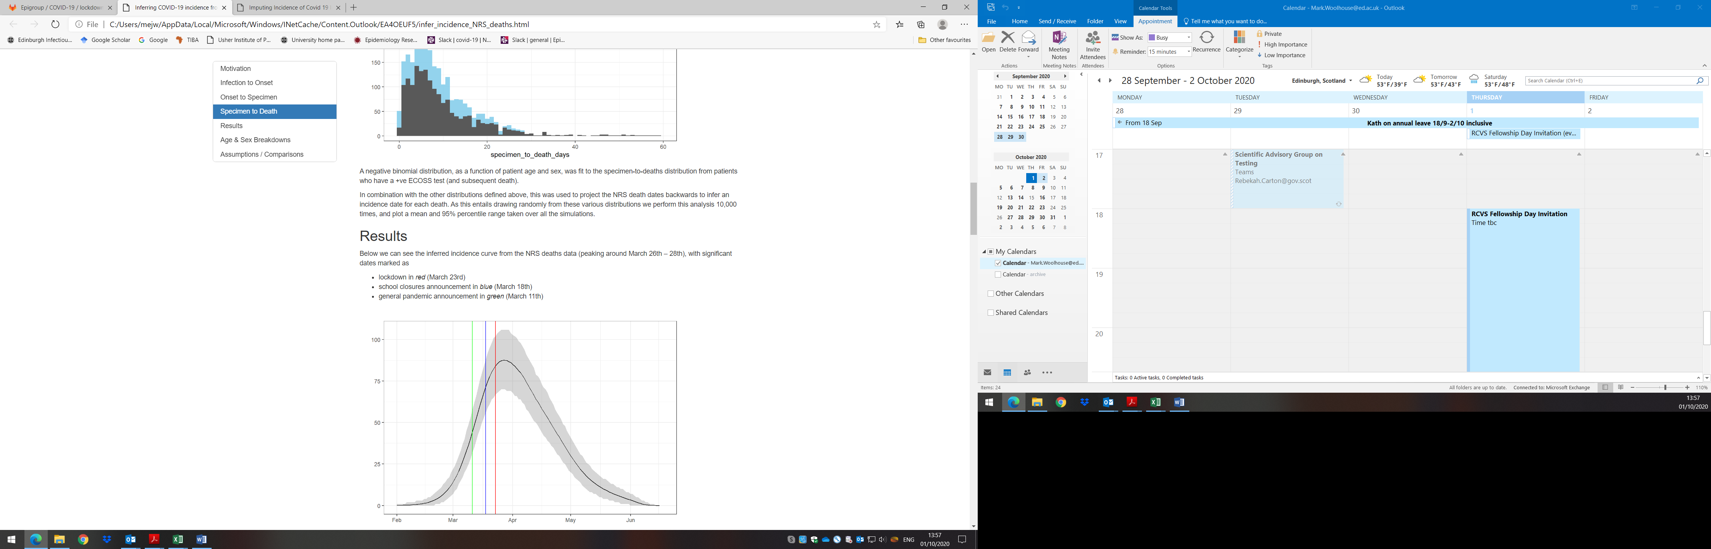

**Figure 2**. SIR model simulations calibrated to an incidence of 150 cases/day on 01/09/20 and 700 cases/day on 01/10/20 (for details see Appendix 2). Key inputs are the delay until interventions are introduced that are effective in reversing the growth in incidence and the post-intervention R value. Key outputs are the absolute number of infections acquired post-01/10/20 (B) and the fraction of all infections these represent (B/A). Scenarios range from optimistic (current interventions are effective, R reduced to 0.7)(top left), to pessimistic (additional interventions are required over the next 14 days, R reduced only to 0.9) (bottom right). In practice the change in incidence is unlikely to be as sharply defined as indicated here.

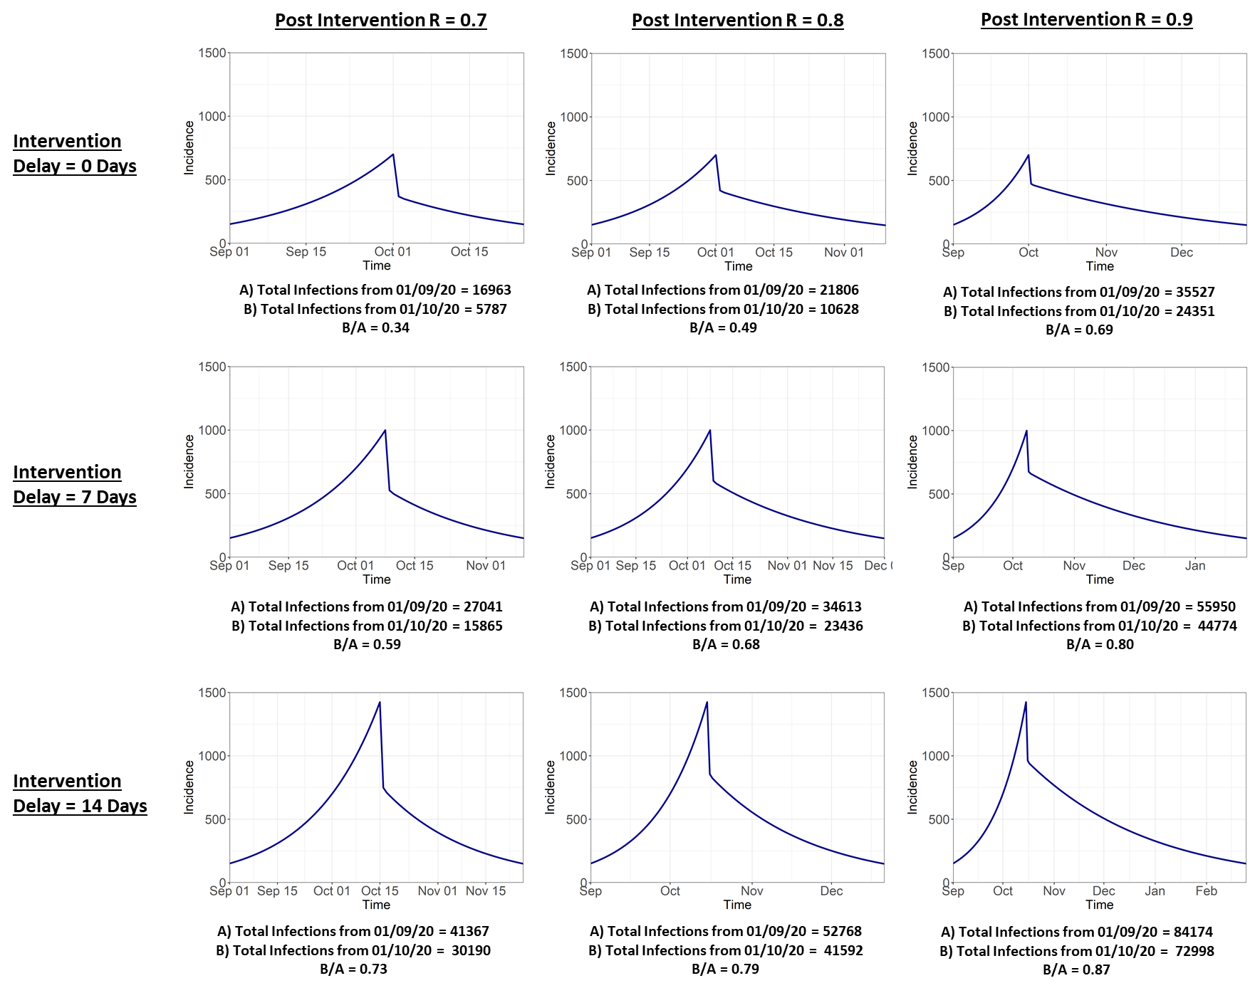

**Table 1**. Calculation of number of COVID-19 deaths (NRS data to June 21 2020) that occurred at intervals after the March 23rd lockdown and the percent of these that occurred outside care homes. The lag is the delay between an infection occurring and death and combines two lags, infection to confirmation and confirmation to death (max. 28 days). A range of lags are considered, of which the most realistic is likely to be 21 days.

|  |  |  |  |  |
| --- | --- | --- | --- | --- |
| Lag (days) | Post-lockdown deaths | % total first wave deaths | Post-lockdown deaths outside care homes | % total post-lockdown deaths |
| 14 | 3157 | 77 | 1482 | 47 |
| **21** | **2507** | **61** | **1135** | **45** |
| 28 | 1846 | 45 | 815 | 44 |
| 35 | 1319 | 32 | 604 | 46 |

**Appendix 1**. Inferring COVID-19 incidence from NRS deaths data – Bob Taylor (PHS), Chris Robertson (Strathclyde/PHS)

Estimating the number of new COVID-19 infections per day is inherently difficult, as it is not generally known when a given patient is infected. Inference based on the number of positive tests is inevitably distorted in unknown ways by e.g. changes in testing strategies. However, dates of death where COVID-19 was a factor are well recorded by NRS. We impute the date of infection using information on

The time from infection to symptoms appearing – The incubation period.

There is no Scottish data on this and published meta analysis distribution is used. A gamma distribution with shape of 5.81 and scale of 0.95 giving a median around 5 days is used.

https://www.acpjournals.org/doi/10.7326/M20-0504#t4-M200504

The time from Symptoms to getting a test

Information in Scotland comes from the GP sentinel surveillance system. This has a mean of about 3.5 days and is fit by a negative binomial distribution.

The time from test to death

There is a great deal of data on this in Scotland from ECOSS linked to NRS deaths data from those who tested positive. This is modelled by a negative binomial distribution with an overall mean of 8.7 days and a size of 2.3, though the mean varied with age and gender and this was used in the imputation.

The imputed date of infection is obtained by sampling from these three distributions, independently, and adding to give an imputed time from infection to death which is then subtracted off the date of death to give an imputed date of infection. This sampling process was repeated 10,000- times and means and 95% confidence intervals are reported.

Key Points

The peak of the imputed date of infection for those who died of Covid 19 in Scotland was after March 23 - around March 26th – 28th

73% of those who died are estimated to have been infection post March 23 (77% of those aged 80+)

Figure 1: Dates of deaths of all people who died of Covid 19 in Scotland to end of June 2020

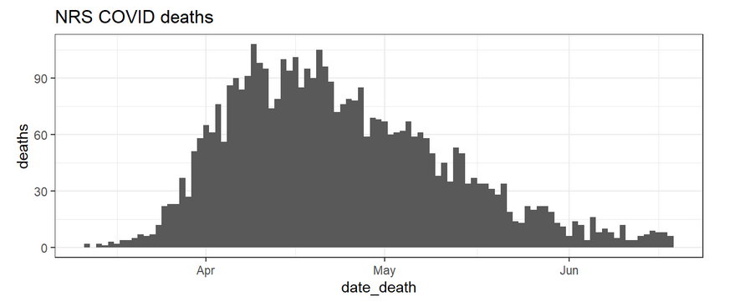

Figure 2: Estimated Infection Curve for all people in Scotland who died of Covid 19.

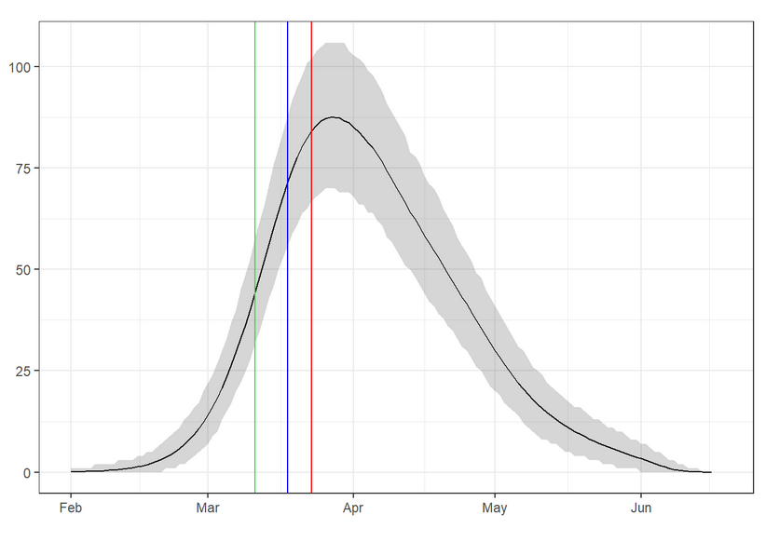

lockdown in red (March 23rd); school closures announcement in blue (March 18th); general pandemic announcement in green (March 11th)

The inferred incidence curve from the NRS deaths data peaked around March 26th – 28th. This suggests that most of the people who died were likely infected after lockdown. 26.8% of those who died are estimated to have been infected prior to 23 March, 2020.

Figure 3: Estimated Infection Curve for all people in Scotland who died of Covid 19 by Age Group and Gender.

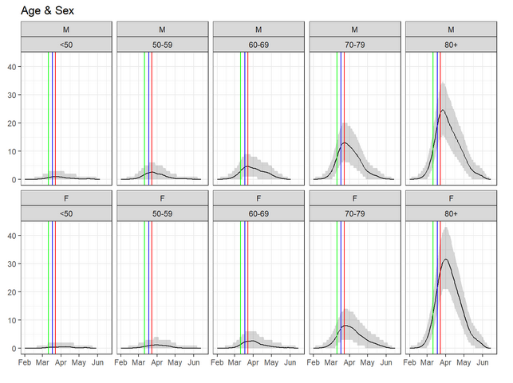

There is a suggestion in the first plot that the peak incidence for the over 80s lies around March 29 to April 01, whereas other age groups' peak coincides more closely with lockdown. The peaks for females appear to occur later than that for all males, especially in the over 80 age group.

Table 1: Percentages of people in Scotland who died of Covid 19 who are estimated to have been infected prior to lockdown on 23rd March

| **Age** | **Percentage** |
| --- | --- |
| Under 50 | 31.1 |
| 50-59 | 40.6 |
| 60-69 | 36.7 |
| 70-79 | 30.6 |
| Over 80 | 23.0 |

**Appendix 2**. Further details of the simulation model used to generate Figure 2.

**Model structure**

**Initial Conditions and Parameter Values**

S(0) = 6,664,160

I(0) = 840

R(0) = 0

*β* = 0.1797 (Using *R* = 1.4)

*γ* = 0.1284 (calculated using *R0* = 2.8 and a doubling time of 3 days)

Parameter values and initial conditions chosen so that:

* At the start of the model simulation (*t* = 0) set at 01/09/20 the incidence is 150 cases/day.
* At 01/10/20 (*t* = 30) the incidence is 700 cases/day.

At baseline, the model Intervention is triggered the day following 1st October (*t* = 31).

**Outcome Measures**

1. Cumulative incidence from the beginning of simulation (01/09/20) until incidence goes back to 150 cases/day.
2. Cumulative incidence from 01/10/20 until incidence goes back to 150 cases/day.
3. Ratio of B/A

**Sensitivity Analysis**

We explore a delay to the intervention of 0/7/14 days and a post-intervention *β* range defined using *R* = 0.9/0.8/0.7.

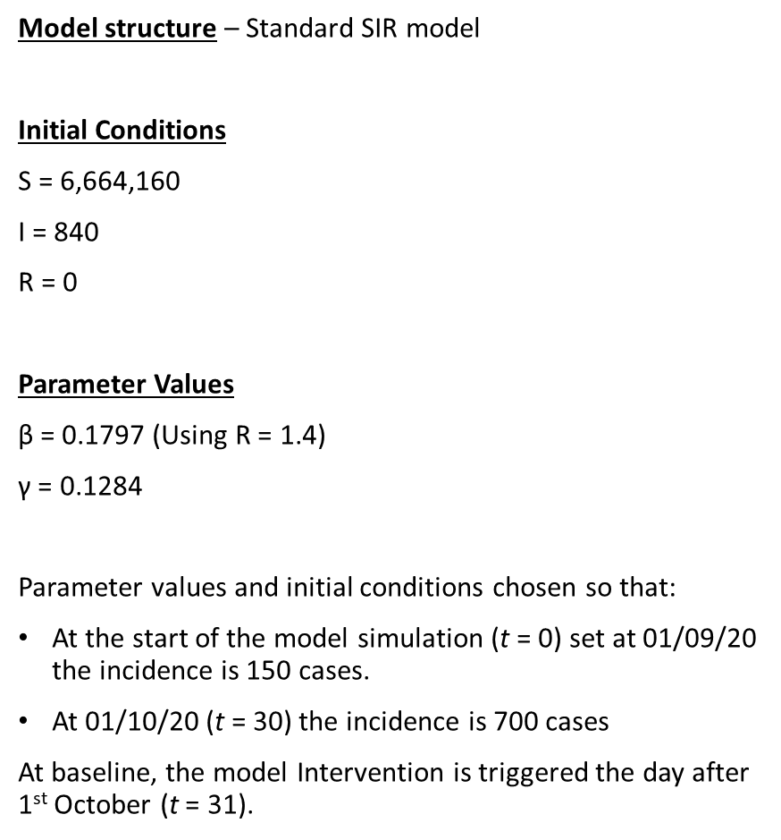

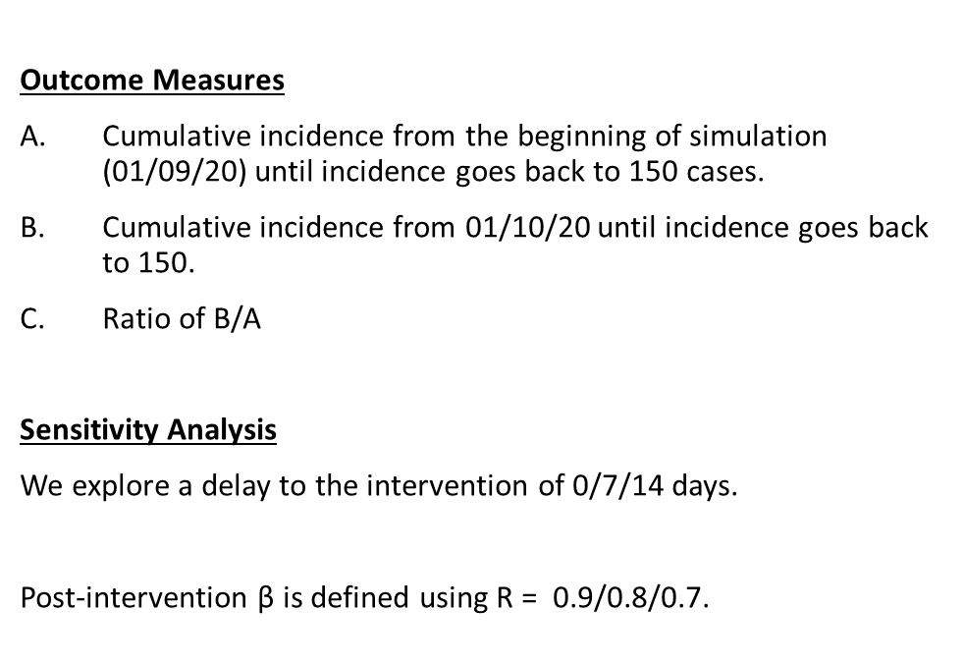

1. Estimates from SPI-M meeting 30/09/20
2. Given 20% population in vulnerable category but having 50% of the infection rate (consistent with seroprevalence data from REACT surveys), so 10% of infections.